Programme 1

Aim
To design and develop a simple static HTML web page for an Online Internship Information
Portal that displays and maintains internship and student record information using ordered lists, unordered lists and tables.

Algorithm / Steps
- Start the program.
- Open a text editor (VS Code/Notepad).
- Create a new .html file.
- Define the HTML structure with <!DOCTYPE html>, <html>, <head>, and <body>.
- Add a title and heading for the portal.
- Use an unordered list to show internship details.
- Use an ordered list to show application steps.
- Create a table to display student records.
- Apply CSS for background, colors, and styling.
- Save and run the file in a browser.
- Stop the program.
CODE:
<!DOCTYPE html>
<html lang="en">
<head>
<meta charset="UTF-8">
<title>Online Internship Information Portal</title>
<style>
body {
font-family: 'Segoe UI', sans-serif;
margin: 0;
padding: 20px;
background: linear-gradient(to right, #74ebd5, #ACB6E5);
}
h1 {
text-align: center;
color: white;
background: #2c3e50;
padding: 20px;
border-radius: 10px;
box-shadow: 0 4px 8px rgba(0,0,0,0.3);
}
h2 {
color: #2c3e50;
margin-top: 30px;
border-bottom: 2px solid #2c3e50;
padding-bottom: 5px;
}
ul {
background: #f9f871;
padding: 15px;
border-radius: 8px;
list-style-type: square;
box-shadow: 0 2px 6px rgba(0,0,0,0.2);
}
ol {
background: #ffcccc;
padding: 15px;
border-radius: 8px;
box-shadow: 0 2px 6px rgba(0,0,0,0.2);
}
table {
width: 100%;
border-collapse: collapse;
margin-top: 20px;
box-shadow: 0 4px 10px rgba(0,0,0,0.2);
}
th, td {
border: 1px solid #2c3e50;
padding: 12px;
text-align: center;
}
th {
background: #2c3e50;
color: white;
}
tr:nth-child(even) {
background: #f1f2f6;
}
tr:hover {
background: #dcdde1;
cursor: pointer;
}
</style>
</head>
<body>
<h1>Online Internship Information Portal</h1>

<h2>Internship Details (Unordered List)</h2>
<ul>
<li>Internship Title: Web Development</li>
<li>Company: Tech Solutions</li>
<li>Duration: 3 Months</li>
<li>Location: Remote</li>
</ul>

<h2>Application Process (Ordered List)</h2>
<ol>
<li>Register on the portal</li>
<li>Upload resume and details</li>
<li>Select preferred internship</li>
<li>Submit application</li>
<li>Attend interview</li>
</ol>

<h2>Student Records (Table)</h2>
<table>
<tr>
<th>Student Name</th>
<th>Department</th>
<th>Year</th>
<th>Internship Applied</th>
<th>Status</th>
</tr>
<tr>
<td>John Doe</td>
<td>Computer Science</td>
<td>3rd Year</td>
<td>Web Development</td>
<td>Pending</td>
</tr>
<tr>
<td>Jane Smith</td>
<td>Information Technology</td>
<td>2nd Year</td>
<td>Data Science</td>
<td>Accepted</td>
</tr>
<tr>
<td>Mark Lee</td>
<td>Electronics</td>
<td>4th Year</td>
<td>AI Research</td>
<td>Rejected</td>
</tr>
</table>
</body>
</html>
OUTPUT: 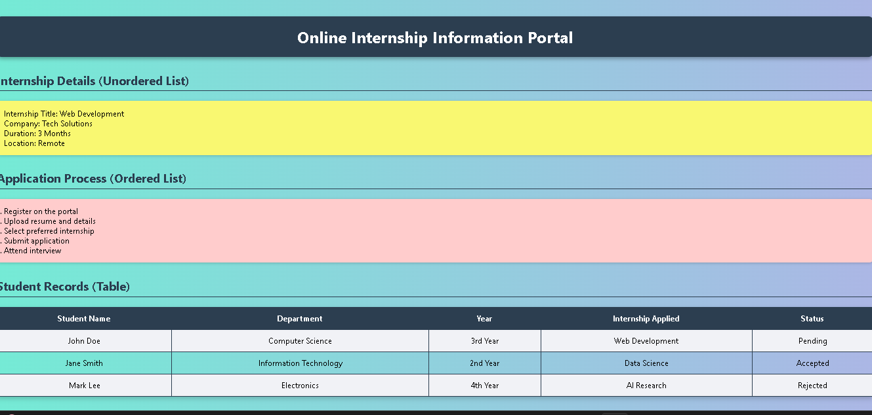
RESULT :
The output displays a simple static HTML webpage for an Online Internship Information Portal with a structured table presents student records clearly, fulfilling the aim of maintaining internship and student information using ordered lists, unordered lists, and tables.

Programme 2
Aim
To design and develop static web pages for an Online Internship Information Portal HTML,
Including:
- Home page with three frames
- Login page
- Catalogue page displaying available internships in a table
- Registration page for new users

Algorithm
- Start the program.
- Create the Home Page using HTML.
- Divide the Home Page into three frames:
- Header frame
- Navigation frame
- Content frame

- Add navigation links in the Home Page to:
- Login Page
- Catalogue Page
- Registration Page
- Design the Login Page using an HTML form with username and password fields.
- Design the Catalogue Page using an HTML table to display available internships with details such as title, company, duration, and location.
- Design the Registration Page using an HTML form to collect user details like name, email, password, gender, and address.
- Link all pages properly using anchor (<a>) tags.
- Save all HTML files and test them in a web browser.
- Stop the program.
CODE:
Index.html
<!DOCTYPE html>
<html>
<head>
<title>Online Internship Information Portal</title>
</head>
<frameset rows="100px,*" border="0">
<frame src="header.html" name="header" noresize>
<frameset cols="200px,*">
<frame src="nav.html" name="nav" noresize>
<frame src="welcome.html" name="content">
</frameset>
</frameset>
</html>
header.html
<!DOCTYPE html>
<html>
<body style="background:#2c3e50; color:white; text-align:center; font-family:Arial; font-size:24px;">
<h1>Online Internship Information Portal</h1>
</body>
</html>
nav.html
<!DOCTYPE html>
<html>
<body style="background:#f39c12; font-family:Arial;">
<h3>Navigation</h3>
<a href="login.html" target="content">Login</a><br>
<a href="catalogue.html" target="content">Internship Catalogue</a><br>
<a href="register.html" target="content">Register</a>
</body>
</html>
welcome.html
<!DOCTYPE html>
<html>
<body style="font-family:Arial; background:#ecf0f1; text-align:center;">
<h2>Welcome to the Internship Portal</h2>
<p>Explore opportunities and apply with ease.</p>
</body>
</html>
login.html
<!DOCTYPE html>
<html>
<body style="background:#dff9fb; font-family:Arial;">
<h2>Login</h2>
<form>
Username: <input type="text" name="username"><br><br>
Password: <input type="password" name="password"><br><br>
<button type="submit">Login</button>
</form>
</body>
</html>
catalogue.html
<!DOCTYPE html>
<html>
<body style="background:#ffeaa7; font-family:Arial;">
<h2>Internship Catalogue</h2>
<table border="1" cellpadding="10" cellspacing="0" style="width:100%; text-align:center;">
<tr style="background:#2c3e50; color:white;">
<th>Internship Title</th>
<th>Company</th>
<th>Duration</th>
<th>Location</th>
</tr>
<tr>
<td>Web Development</td>
<td>Tech Solutions</td>
<td>3 Months</td>
<td>Remote</td>
</tr>
<tr>
<td>Data Science</td>
<td>DataWorks</td>
<td>6 Months</td>
<td>Onsite</td>
</tr>
<tr>
<td>AI Research</td>
<td>Innovate Labs</td>
<td>4 Months</td>
<td>Hybrid</td>
</tr>
</table>
</body>
</html>
register.html
<!DOCTYPE html>
<html>
<body style="background:#f9f871; font-family:Arial;">
<h2>Registration</h2>
<form>
Name: <input type="text" name="name"><br><br>
Email: <input type="email" name="email"><br><br>
Password: <input type="password" name="password"><br><br>
Gender:
<input type="radio" name="gender" value="Male"> Male
<input type="radio" name="gender" value="Female"> Female<br><br>
Address: <textarea name="address"></textarea><br><br>
<button type="submit">Submit</button>
<button type="reset">Reset</button>
</form>
</body>
</html>
OUTPUT:

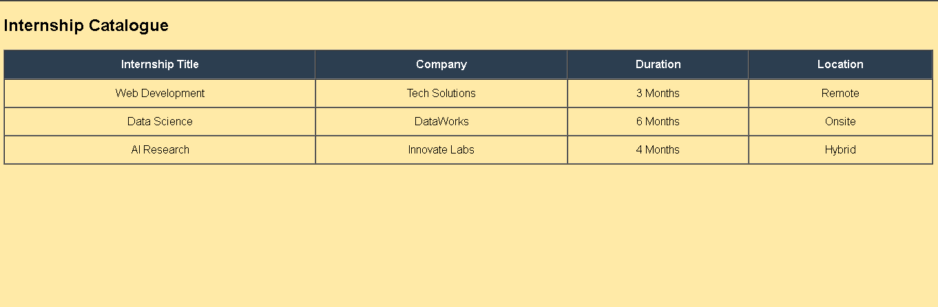
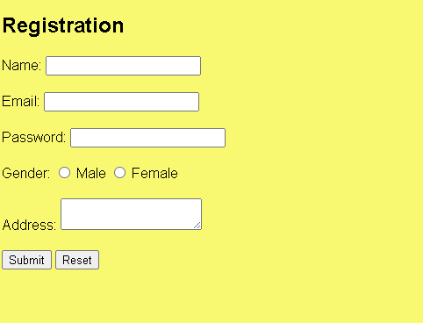

Result
Thus, static web pages for an Online Internship Information Portal were successfully designed using HTML with a colorful, professional layout including a framed home page,
login page, internship catalogue, and registration page.

Programme 3
Aim
To design and develop an HTML web page using anchor (<a>) tags and an iframe to display linked content within the same page, where the iframe loads a web page containing an image using the <img> tag for the Online Internship Information Portal.

Algorithm / Steps
- Create a main HTML page with a heading for the Online Internship Information Portal.
- Add anchor (<a>) tags to link different sections like internship details, application process, and student records.
- Insert an iframe (<iframe>) to display linked content within the same page.
- Design a separate HTML page (imagepage.html) containing an internship-related image using the <img> tag.
- Ensure the anchor links load the image page inside the iframe for a professional, colorful output.
CODE:
index1.html
<!DOCTYPE html>
<html lang="en">
<head>
<meta charset="UTF-8">
<title>Online Internship Information Portal</title>
<style>
body {
font-family: Arial, sans-serif;
background: linear-gradient(to right, #74ebd5, #ACB6E5);
text-align: center;
padding: 20px;
}
h1 {
background: #2c3e50;
color: white;
padding: 15px;
border-radius: 8px;
box-shadow: 0 4px 8px rgba(0,0,0,0.3);
}
a {
display: inline-block;
margin: 15px;
padding: 10px 20px;
background: #f39c12;
color: white;
text-decoration: none;
border-radius: 5px;
font-weight: bold;
}
a:hover {
background: #d35400;
}
iframe {
margin-top: 20px;
border: 2px solid #2c3e50;
border-radius: 8px;
}
</style>
</head>
<body>
<h1>Online Internship Information Portal</h1>
<p>Click below to view internship-related image inside the iframe:</p>
<a href="imagepage.html" target="iframeDisplay">View Internship Image</a>

<iframe name="iframeDisplay" width="600" height="400"></iframe>
</body>
</html>
imagepage.html
<!DOCTYPE html>
<html lang="en">
<head>
<meta charset="UTF-8">
<title>Internship Image</title>
</head>
<body style="background:#ecf0f1; text-align:center; font-family:Arial;">
<h2>Internship Opportunity</h2>
<img src="internship.jpg" alt="Internship Image" width="500" height="300" style="border:3px solid #2c3e50; border-radius:10px;">
</body>
</html>
OUTPUT:
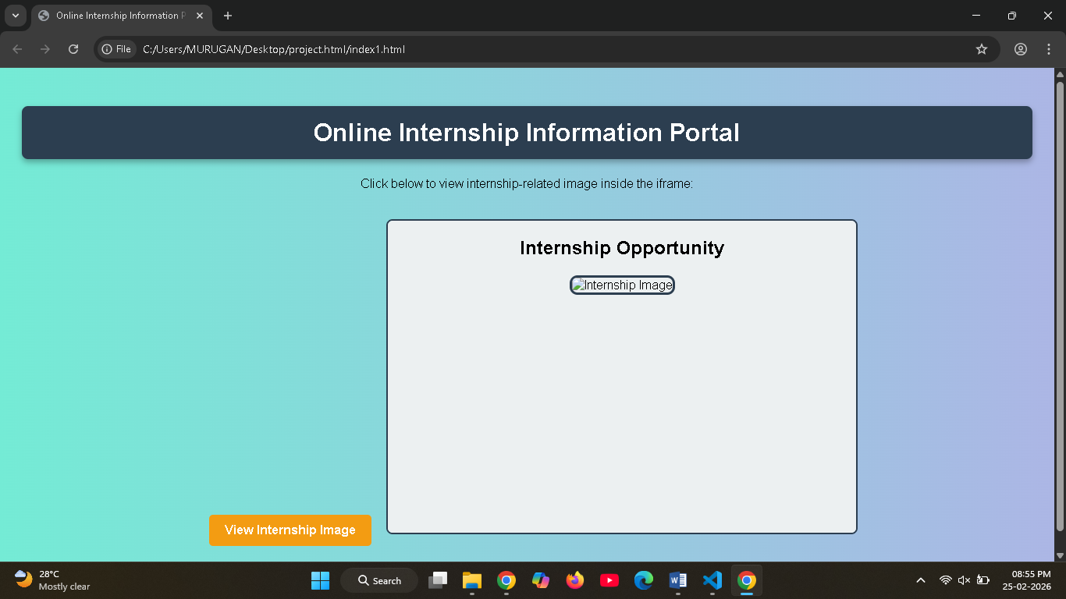

Result
Thus, the iframe was successfully used to display iternship opportunity dynamically.

Programme 4
Aim
To design and develop an HTML web page containing a submission form for an Online Internship Information Portal, where students can enter details such as Name, Email, Branch, Gender, and Address using appropriate HTML form elements.

Algorithm / Steps
- Create a new HTML file named internship_form.html.
- Build the basic HTML structure with <!DOCTYPE html>, <html>, <head>, and <body>.
- Add a heading and create a form using the <form> tag with action and method attributes.
- Insert input fields for Name, Email, Branch (dropdown), Gender (radio buttons), and Address (textarea).
- Add Submit and Reset buttons, save the file, and run it in a browser to verify functionality.

CODE:
internship_form.html
<!DOCTYPE html>
<html lang="en">
<head>
<meta charset="UTF-8">
<title>Internship Information Submission Form</title>
<style>
body {
font-family: Arial, sans-serif;
background: linear-gradient(to right, #fbc2eb, #a6c1ee);
margin: 0;
padding: 20px;
}
h1 {
text-align: center;
background: #2c3e50;
color: white;
padding: 15px;
border-radius: 8px;
box-shadow: 0 4px 8px rgba(0,0,0,0.3);
}
form {
background: #ffffff;
padding: 20px;
border-radius: 10px;
width: 50%;
margin: auto;
box-shadow: 0 4px 10px rgba(0,0,0,0.2);
}
label {
font-weight: bold;
display: block;
margin-top: 10px;
}
input, select, textarea {
width: 100%;
padding: 8px;
margin-top: 5px;
border: 1px solid #ccc;
border-radius: 5px;
}
button {
margin-top: 15px;
padding: 10px 20px;
border: none;
border-radius: 5px;
background: #27ae60;
color: white;
font-weight: bold;
cursor: pointer;
}
button:hover {
background: #219150;
}
</style>
</head>
<body>
<h1>Internship Information Submission Form</h1>
<form action="submit.html" method="POST" id="internshipForm">
<label for="name">Name:</label>
<input type="text" id="name" name="student_name" placeholder="Enter your name" required>

<label for="email">Email:</label>
<input type="email" id="email" name="email" placeholder="Enter your email" required>

<label for="branch">Branch:</label>
<select id="branch" name="branch" required>
<option value="">Select Branch</option>
<option value="CSE">CSE</option>
<option value="IT">IT</option>
<option value="ECE">ECE</option>
<option value="EEE">EEE</option>
<option value="MECH">MECH</option>
</select>

<label>Gender:</label>
<input type="radio" name="gender" value="Male" required> Male
<input type="radio" name="gender" value="Female" required> Female

<label for="address">Address:</label>
<textarea id="address" name="address" rows="4" placeholder="Enter your address" required></textarea>

<button type="submit">Submit</button>
<button type="reset">Reset</button>
</form>
</body>
</html>

OUTPUT:


Result
Thus, an HTML web page titled Internship Information Submission Form was successfully
designed and executed to collect student details using various HTML elements .

Programme 5
Aim
To design and develop a web page for an Online Internship Information Portal that embeds a map and provides hot spots, frames, and hyperlinks to navigate and display related internship content.

Algorithm / Steps
- Create the main page (index.html) with frames for navigation and content display.
- Add navigation links using anchor (<a>) tags to load pages into the content frame.
- Embed a map in map.html using an image with defined hot spots (<map> and <area> tags).
- Link hot spots to content.html so that clicking on regions loads related internship information.
- Save all files and run index.html in a browser to verify navigation, frames, and hot spot functionality.
CODE:
index2.html
<!DOCTYPE html>
<html>
<head>
<title>Online Internship Information Portal</title>
</head>
<frameset cols="200px,*">
<frame src="nav.html" name="nav">
<frame src="map.html" name="content">
</frameset>
</html>
nav1.html
<!DOCTYPE html>
<html>
<body style="background:#f39c12; font-family:Arial;">
<h3>Navigation</h3>
<a href="map.html" target="content">Internship Map</a><br>
<a href="content.html" target="content">Internship Details</a>
</body>
</html>
map.html
<!DOCTYPE html>
<html>
<body style="background:#ecf0f1; text-align:center; font-family:Arial;">
<h2>Internship Locations Map</h2>
<!-- Replace internship_map.jpg with your actual map image -->
<img src="internship_map.jpg" usemap="#internshipmap" alt="Internship Map"
width="600" height="400" style="border:2px solid #2c3e50; border-radius:8px;">

<map name="internshipmap">
<!-- Hot spot for Web Development Internship -->
<area shape="rect" coords="50,50,150,150" href="content.html" target="content" alt="Web Development Internship">
<!-- Hot spot for Data Science Internship -->
<area shape="circle" coords="300,200,50" href="content.html" target="content" alt="Data Science Internship">
<!-- Hot spot for AI Research Internship -->
<area shape="rect" coords="400,100,550,200" href="content.html" target="content" alt="AI Research Internship">
</map>
</body>
</html>
content.html
<!DOCTYPE html>
<html>
<body style="background:#dff9fb; font-family:Arial; text-align:center;">
<h2>Internship Details</h2>
<p>Clicking on a hot spot in the map displays related internship information here.</p>
<p>Example: Web Development Internship – Company: Tech Solutions, Duration: 3 Months, Location: Remote.</p>
</body>
</html>
OUTPUT:
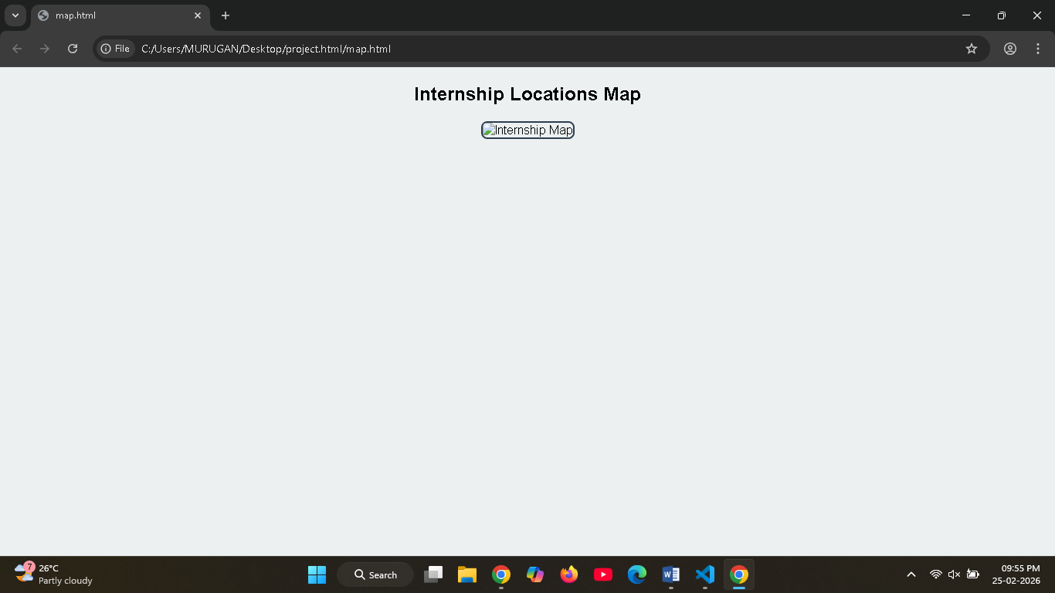
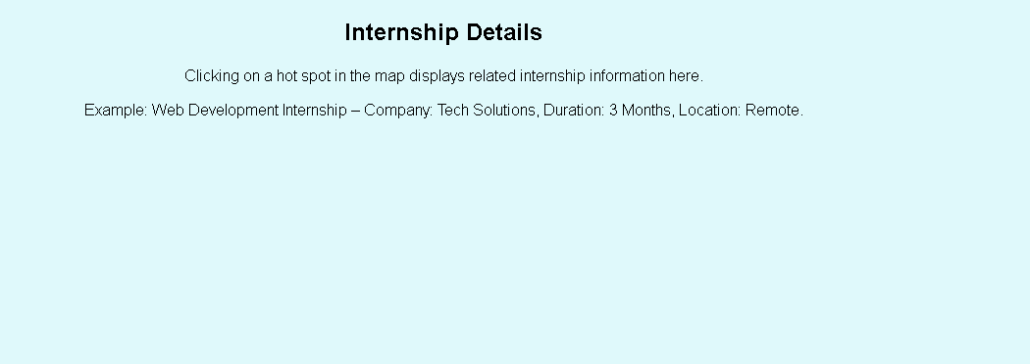

Result
Thus, a web page embedding a map using hot spots, frames, and hyperlinks is successfully designed and executed.

